**In-Game Events**

**Bulbasaur, Charmander & Squirtle**

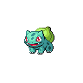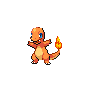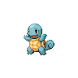

**Bulbasaur** can be obtained by talking to the Lady in the house in Cerulean City

**Charmander** can be obtained by talking to the Boy at the top of Route 24

**Squirtle** can be obtained by talking to the Lass in the Centre of Vermillion City

**Chikorita, Cyndaquil & Totodile**

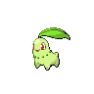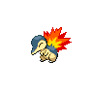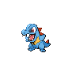

**Chikorita** can be caught at the Entrance of Route 9

**Cyndaquil** can be caught behind Digletts Cave on Route 2

**Totodile** can be caught by the Gym in Vermillion City

**Treecko, Torchic & Mudkip**

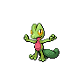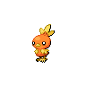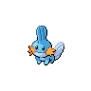

**Treecko** can be caught outside Mt. Moon on Route 4

**Torchic** can be obtained at the Entrance of Route 3

**Mudkip** can be obtained in the Garden at Cerulean City

**Castform, Chimecho & Togepi**

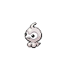 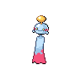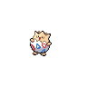

**Castform** can be obtained as an Egg from the Scientist outside the Fuchsia City Gym

**Chimecho** can be obtained as an Egg from the Man standing outside the House in the Safari Zone

**Togepi** can be obtained as an Egg from the Girl standing outside the Pewter City Gym

**Eevee**

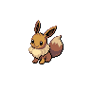

**Eevee** can be obtained as an event Pokémon in Vermillion City

**Dratini & Bagon**

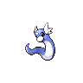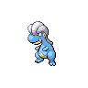

**Dratini** can be obtained as a gift Pokémon from the Dragon Dojo in Saffron City

**Bagon** can be obtained as a gift Pokémon from the Dragon Dojo in Saffron City

To get the alternative of your choice, both Dratini & Bagon can be found at the Safari Zone with low encounter rates.

**Sudowoodo & Beldum**

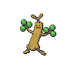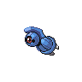

**Sudowoodo** can be found and caught blocking the path on Route 7

**Beldum** can be obtained from the Cool Trainer by the Tree in Celadon City

**Kabuto, Omanyte, Lileep & Anorith**

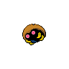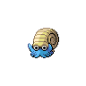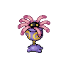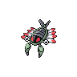

**Kabuto, Omanyte, Lileep & Anorith** can all be obtained as an Egg from the Man in Glasses outside Celadon City Gym.

**Kyogre, Groudon & Rayquaza**

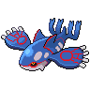 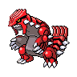 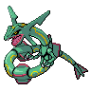

**Kyogre** can be found in a new Cave situated on Route 4

**Groudon** can be found in a new Cave situated on Route 4

**Rayquaza** can be obtained as an Egg from Mr. Fuji on Four Island

**Latios & Latias**

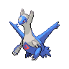 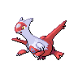

**Latios** can be found in Soul Cave which is situated in Victory Road

**Latias** can be found in Soul Cave which is situated in Victory Road

**Regirock, Registeel & Regice**

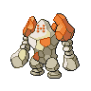 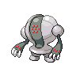 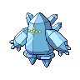

**Regirock** can be found in a new Cave situated on Route 22

**Registeel** can be found in a new Cave situated on Route 10

**Regice** can be found in a new Cave situated on Route 12

**Entei, Suicune & Raikou**

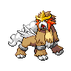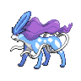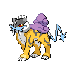

**Entei** can be found at Five Isle Meadow

**Suicune** can be found in Icefall Cave

**Raikou** can be found on Six Island

**Mew, Celebi & Jirachi**

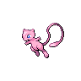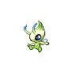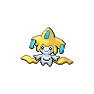

**Mew** can be found in Cerulean Cave on the same floor as Mewtwo

**Celebi** can be obtained on Route 23 near the entrance of Victory Road

**Jirachi** can be obtained as an Egg from the Scientist on Cinnabar Island

**Ho-Oh & Lugia**

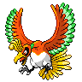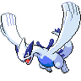

**Ho-Oh** can be found at Navel Rock which can now be accessed via Route 24

**Lugia** can be found at Navel Rock which can now be accessed via Route 24

**Deoxys**

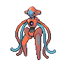

**Deoxys** can be found at Birth Island which can now be accessed via Route 3